Time Stress

The problem
- In our society, time has become one of our biggest stressors.
- We wonder where has time gone, the day, the week the year?
- It can feel like there is not enough time

The Solution:
- Mindfulness proposes ‘non-doing’

The challenge
- To put this to the test in your own life.
- How – The answer is simple and not at all farfetched
- Inner peace exists outside of time.
- Commit to spending some time everyday in inner stillness – even for 2 minutes, or five, or ten.
- The calmness, relaxation, and centering that come from letting go of time transform your experience of time when you go back into it.

Four ways to free yourself from the tyranny of time

Just because the world has speeded up through technology is no reason for us to be ruled by it to the point where we are stressed beyond all our limits and perhaps driven to an early grave by the treadmill of modern life.
- Time is a product of thought – Einstein said ‘if you are sitting on a hot stove a minute can seem like an hour, but if you are doing something pleasurable, an hour can seem like a minute’. Think of the last good party and bad party you went to – did time feel different at each occasion?
- Live in the present more of the time (be aware of how much time and energy you spend on past and future worry – this leads to a time scarcity mentality of ‘not having enough time’)
- Meditate each day
- Simplify your life in certain ways. (how much TV do you watch, newspapers do you read, time on Facebook)?

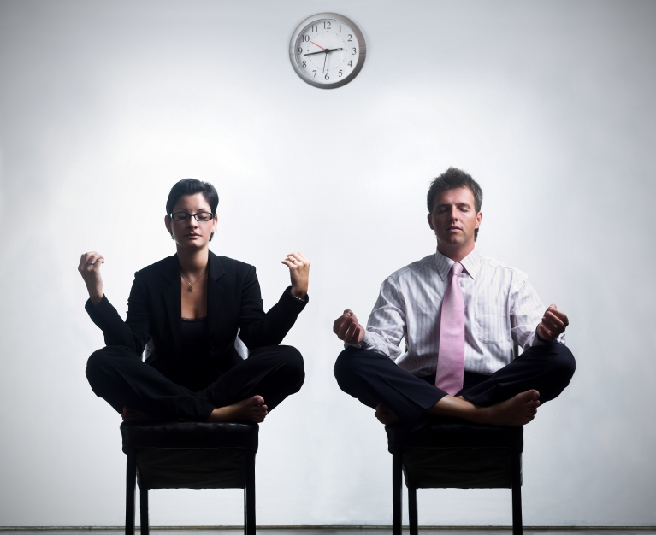

Work Stress

Work is a major part of our lives. We spend a lot of time at work, and it costs a lot of our energy. With fears of job losses, redundancies and closures, these uncertain times can make the work environment an extra stressful environment. The people we work with can add to this stress. Time pressure, expectations, and a challenging economic backdrop can play a major role in our work lives that can compound directly to physical and emotional stress. Here’s how you can take mindfulness in a very practical way into your workspace.

How to reduce Work stress through mindfulness

- When you wake up, take a few moments to affirm that you are choosing to work today. If you can, briefly review what you think you will be doing and remind yourself that it may or may not happen that way.
- Bring awareness to the whole process of preparing to go to work. This might include showering, dressing, eating, and relating to the people that you live with. Tune into your breathing.
- Don’t say good-bye mechanically to people, make eye contact, kiss goodbye.
- If you take public transport, be ware of your body walking, standing and waiting, and getting off. Walk into work mindfully.
- If driving, some days drive with the radio off, and consciously breathe.
- How is your bodily sensations at work, do you have any tension in your shoulders, jaw, back? How do you sit or stand at work? Consciously let go of any tension.
- Really use your breaks, instead of coffee and or a cigarette, walk around the outside of your building.
- Do neck and shoulder rolls at your desk.
- Sometimes change what you do at lunch. Spend it with people you are comfortable with. Or you could sometimes try it on your own.
- Do mini-meditations at work, tune in to yourself and become aware of your breathing.
- Do other people affect your mood? Be aware of people who seem to be in a hostile mode with you. Think about how you might approach them more effectively? How might awareness of tone of voice and body language help you when communicating?
- At the end of the day, review what you have accomplished and make a list of what needs to be done tomorrow. Prioritise the items on your list so that you know what is most important.
- When you are leaving, be aware of the transition. Monitor your body. Are you exhausted? Are you standing erect or bent over? What expression is on your face?
- If taking public transport, notice if you are rushing. Can you tune into yourself between work and home and own these moments for yourself?
- If driving can you drive home mindfully?
- When you get home, before you walk in the door, ‘come home’ how to do you announce your arrival, with a smile, or with tension or fatigue?
- A good transition from work to home is to change your clothes. Could you take 5 minutes to meditate before making the dinner?

From ‘Full Catastrophe Living’ – Jon Kabat-Zinn

